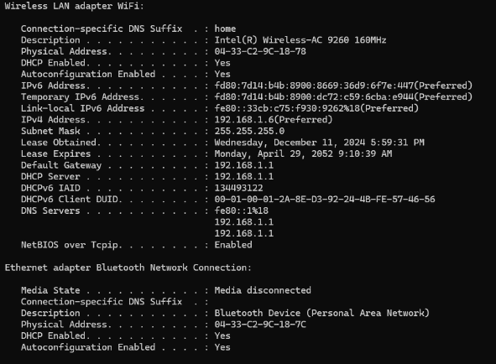**Assignment 1:**

1.Mac adress : 04-33-C2-9C-18-78  
2.Public IP adress: [156.197.41.205](https://www.whatismyip.com/ip/156.197.41.205/)

1

3.Private IP adress:

* IPv4 Address - 192.168.1.6
* Ipv6 Address -fd80:7d14:b4b:8900:8669:36d9:6f7e:447

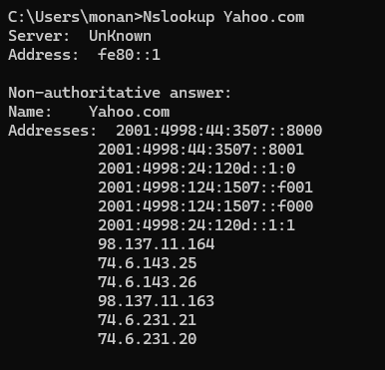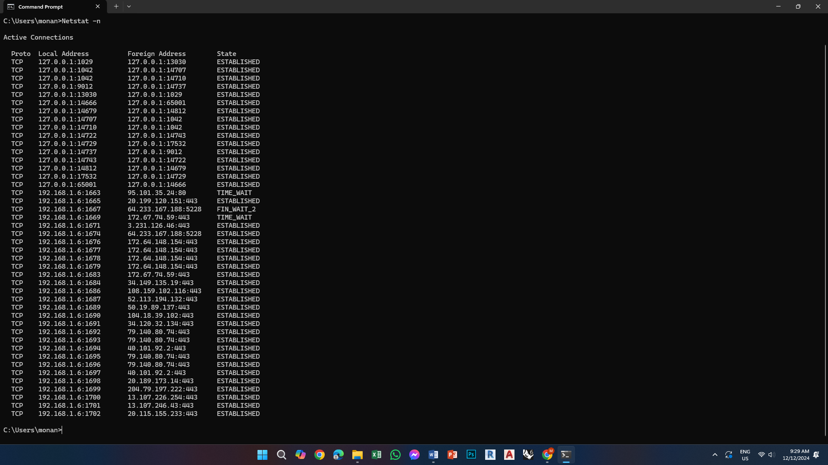4. Current sessions and ports:

5.Yahoo.com IPs:

**Assignment 2:**

**Stoping Dos attack from zombie device using local firewall to block a port:**

1. 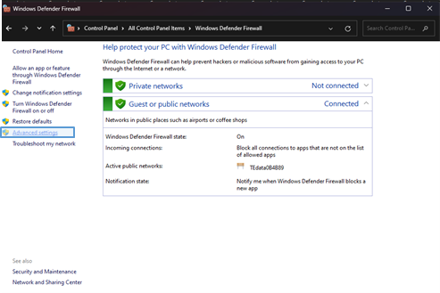Open Windows Firewall:   
   controlpanel => windowes defender firewall => advanced settings
2. 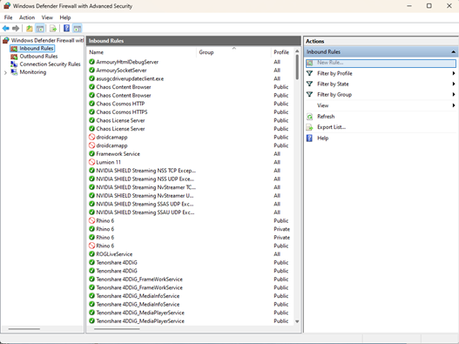Create a New Inbound Rule: Inbound Rules => New Rule
3. 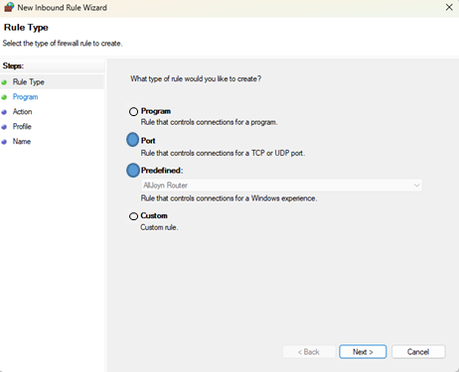Block the Port or IP adress:   
   select port for ports or custome for IP:

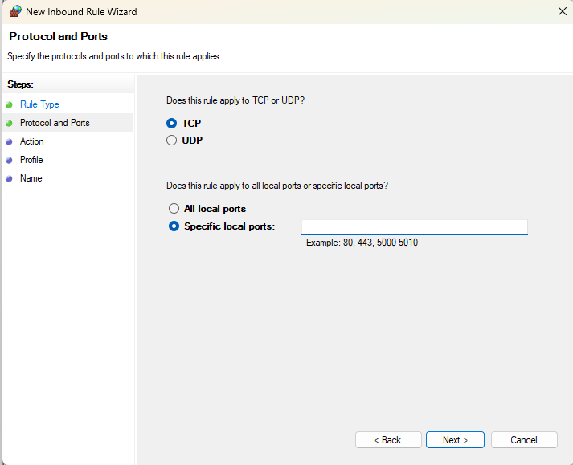  
for ports : choose TCP or UDP based on the port and enter port number

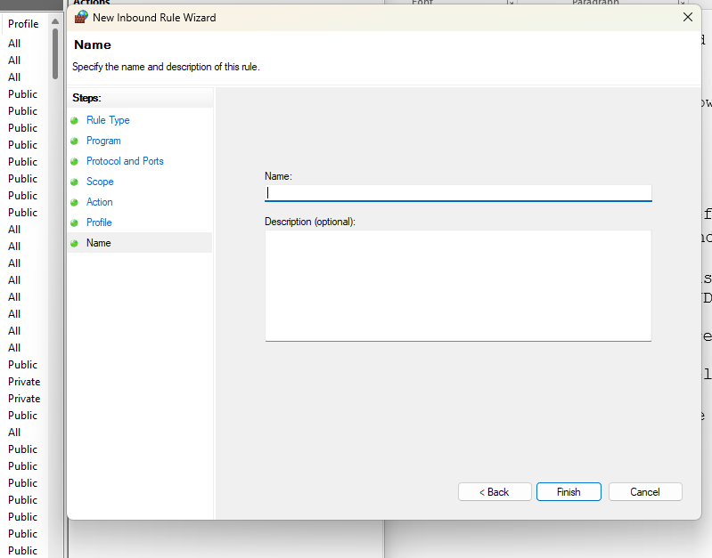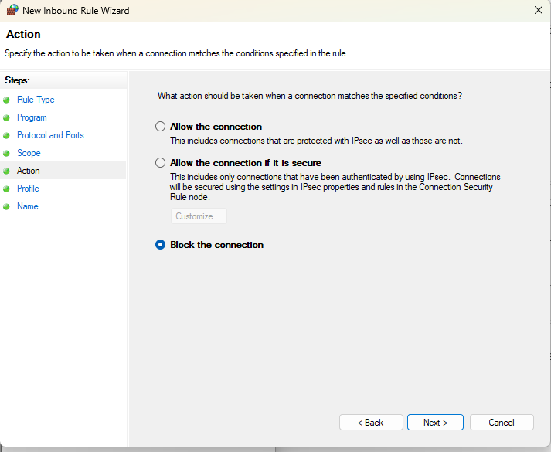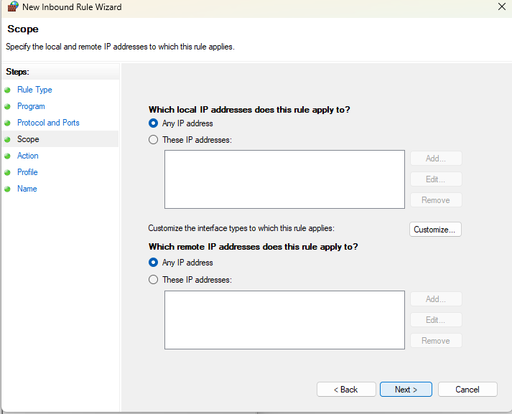  
for the IP : add the ip adress to which remote IP adresses does this rule apply too   
  
after that in both cases select block the connection => name the role and finish

1. 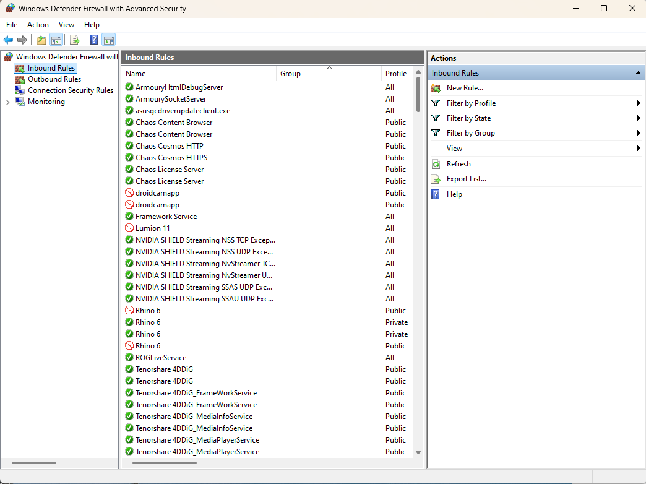Verify the Rule: now you can see the role in the inbiund rule list

**Assignment 3:**

**Using Vmware workstation to host windows 10 as a virtual machine alongside the current operating system :**

1. 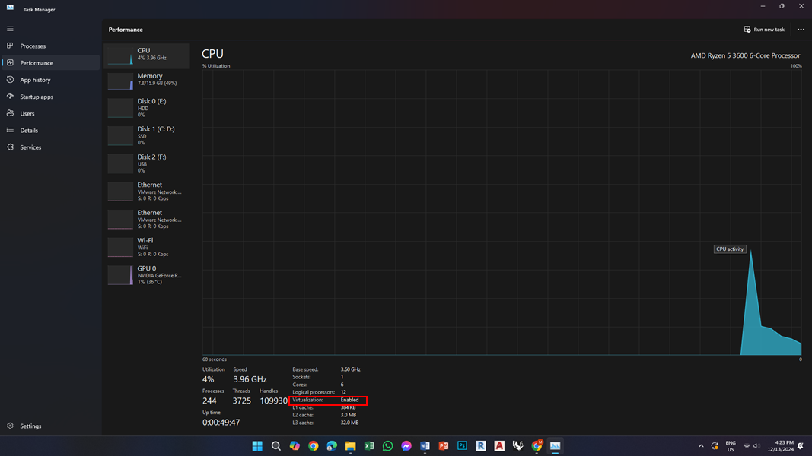**installing VMware Workstation and making sure the Virtualization is enabled in Bios :**
2. 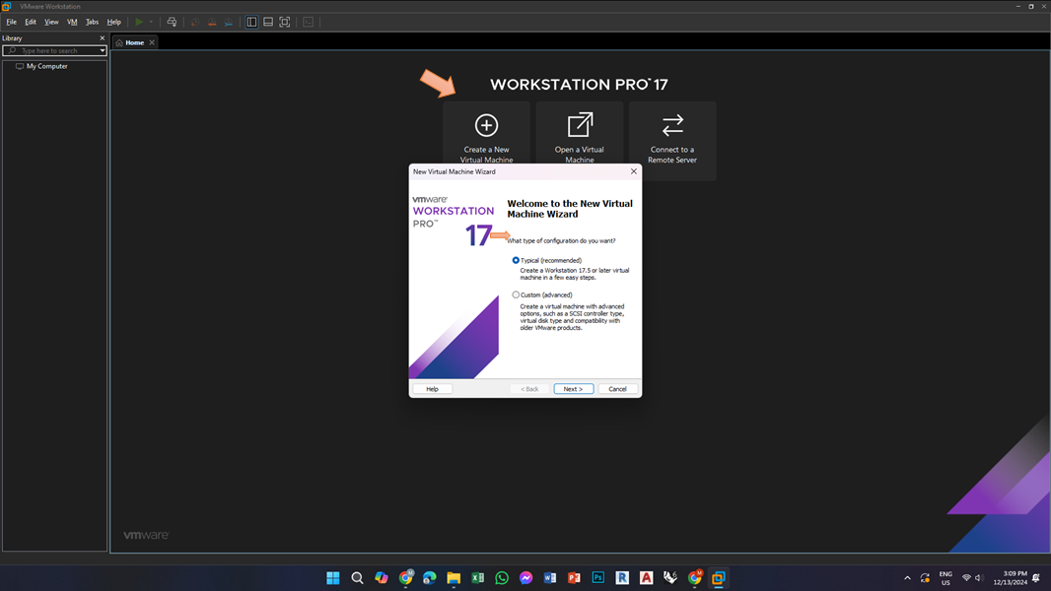**Create a New Virtual Machine** => **choose** **Typical:**
3. 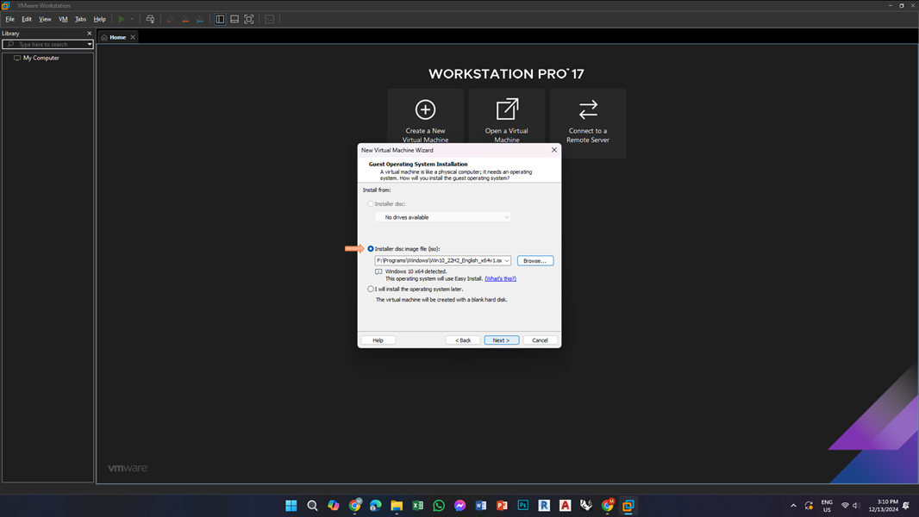**Select Installer Disk Image => Browsr Windows 10 ISO file:**
4. 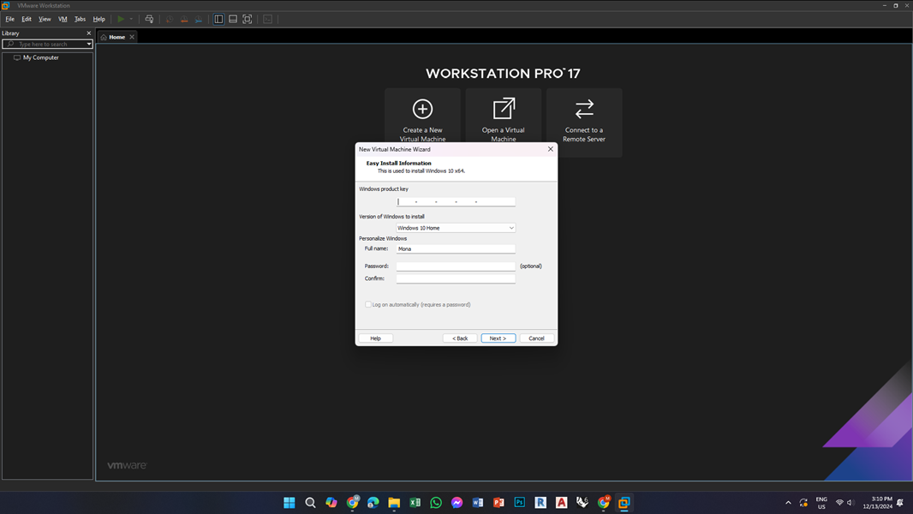**Enter Virtual Machine Details (product key, username ,password, ...)**
5. 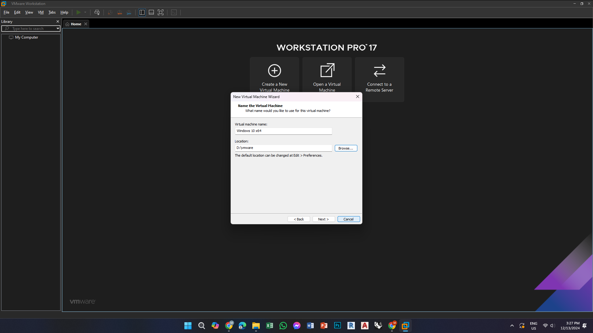**Configure Virtual Machine Name and location:**
6. 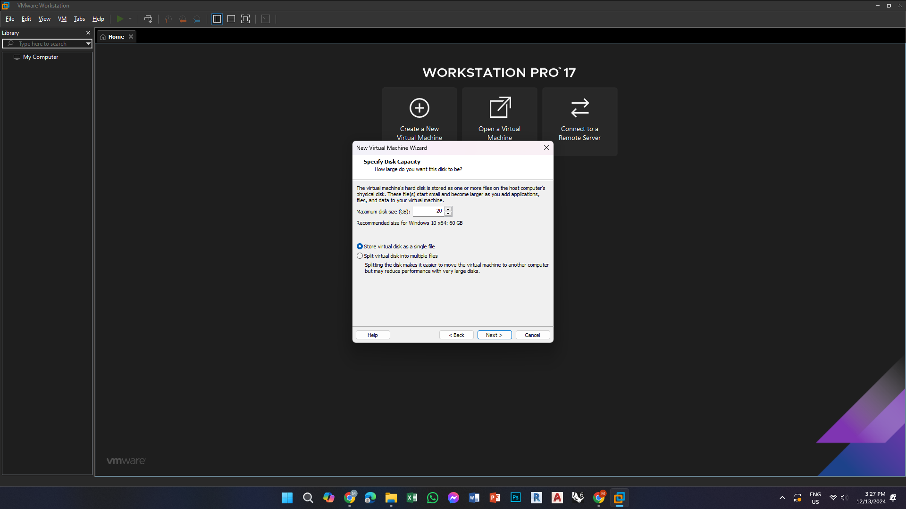Allocate an amount of disk space for the virtual machine and select to store the virtual disk as a
7. 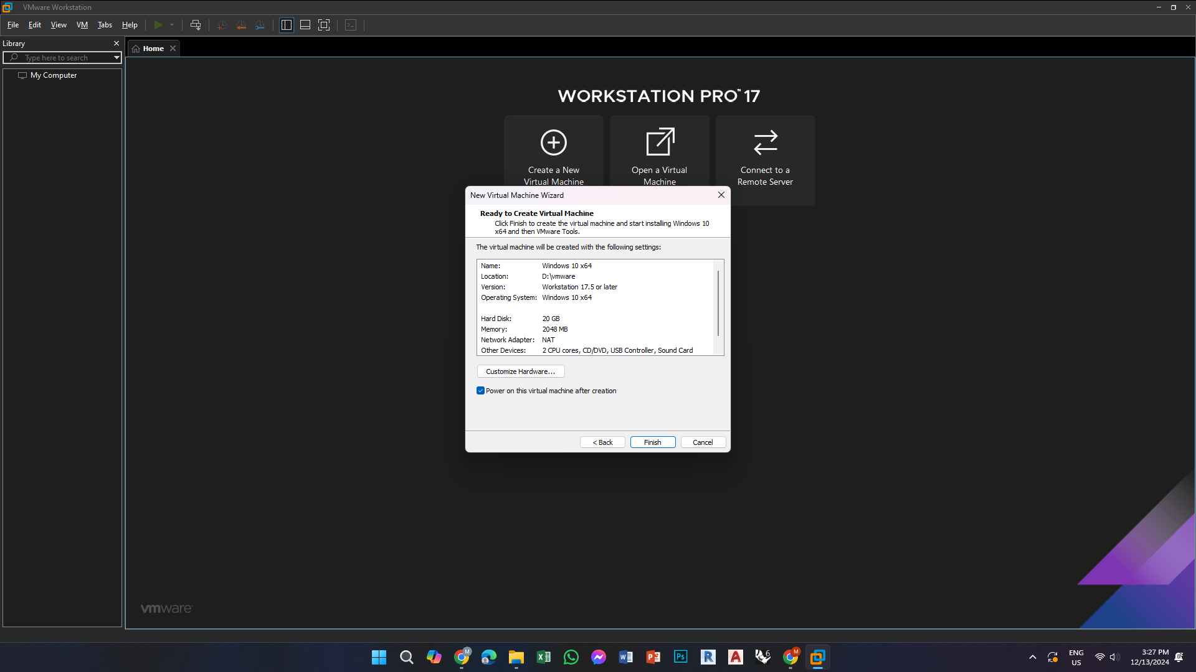**Customize Hardware if neede (alloctaing more ram , change network adapter, ...)**
8. 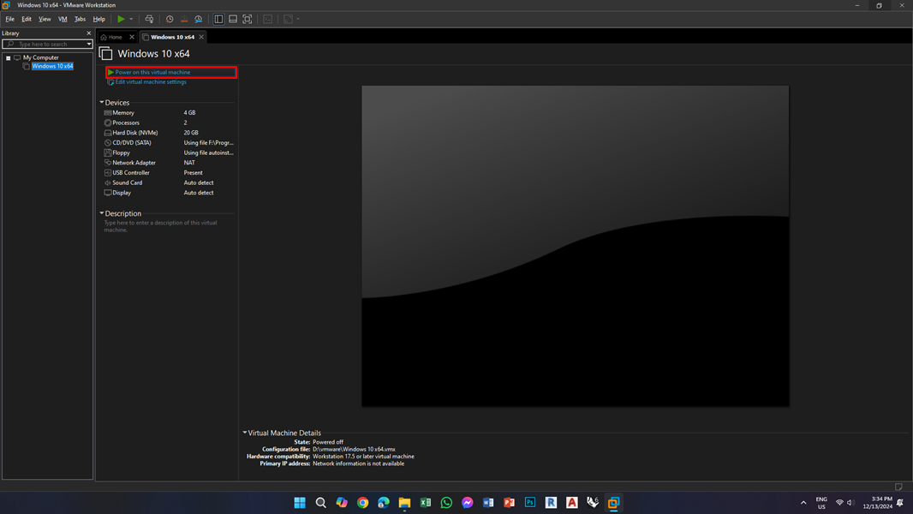**Finish and Power On:**
9. 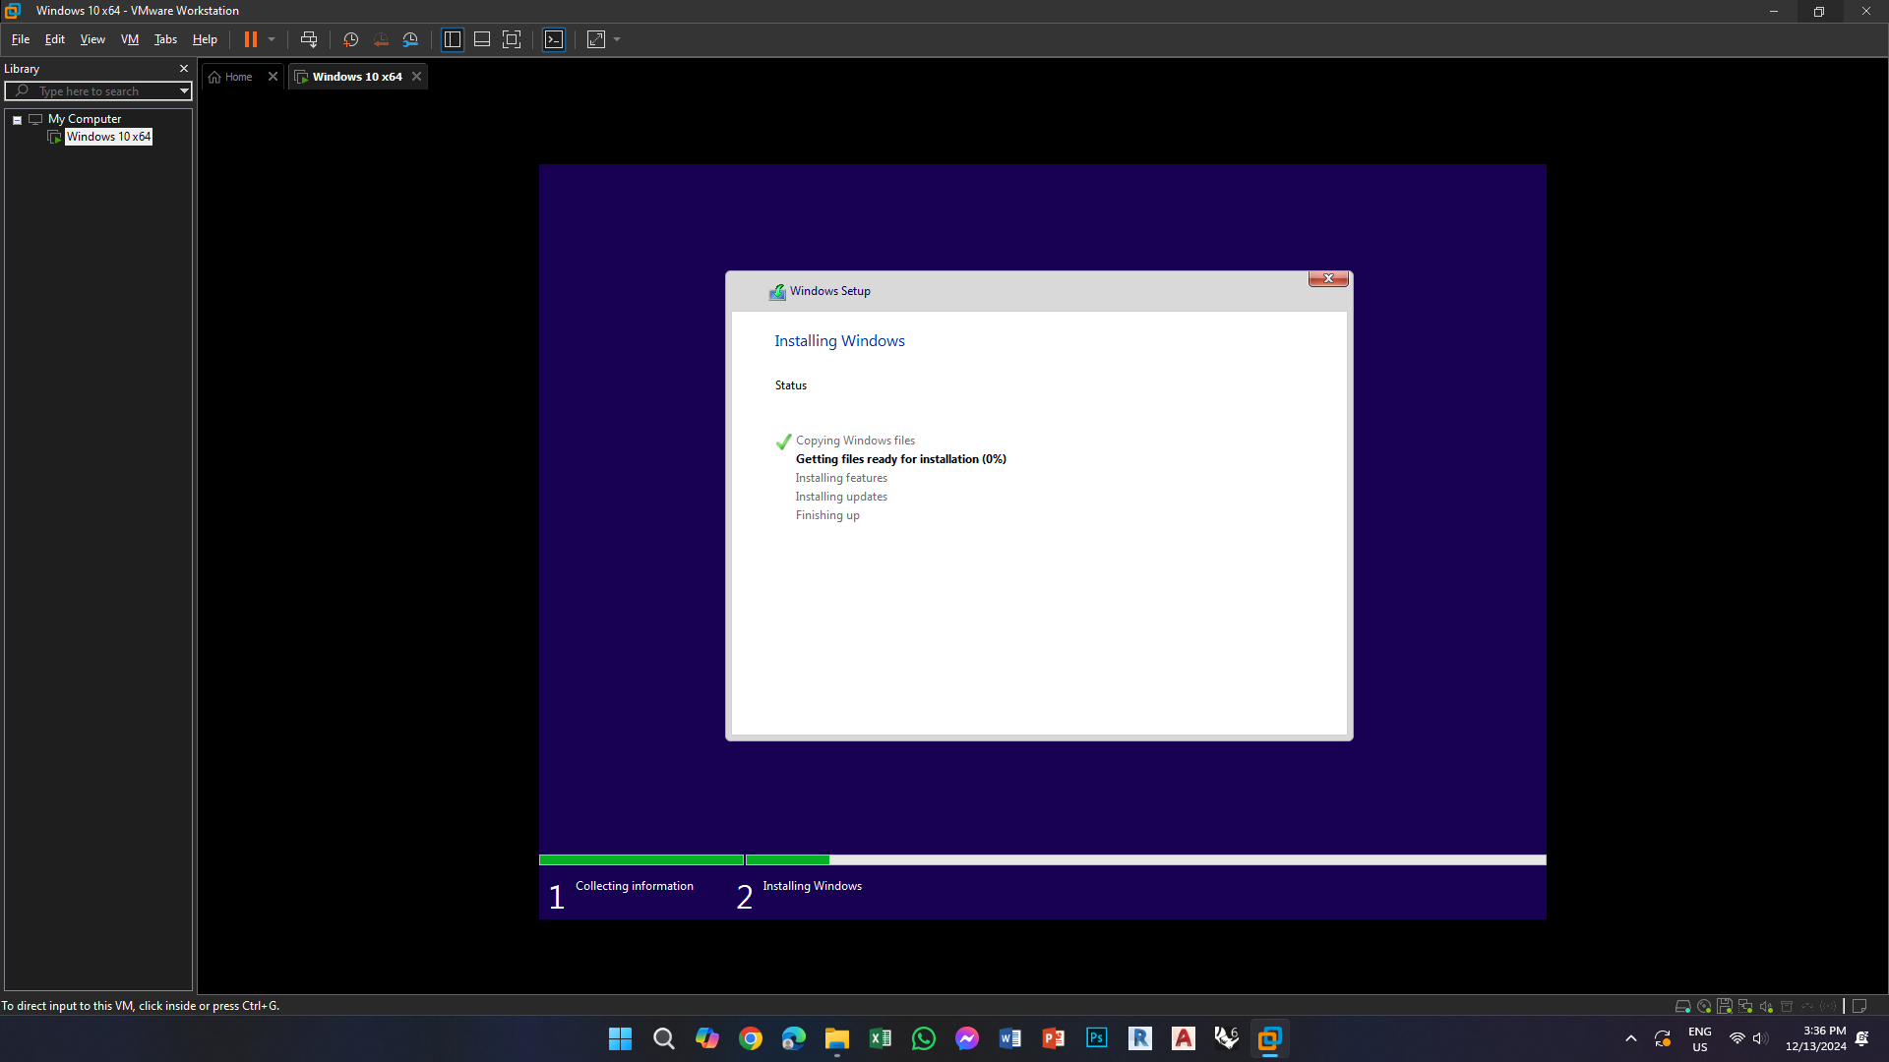**Install Windows 10:**
10. After instalition is done use windows 10 as you like :



